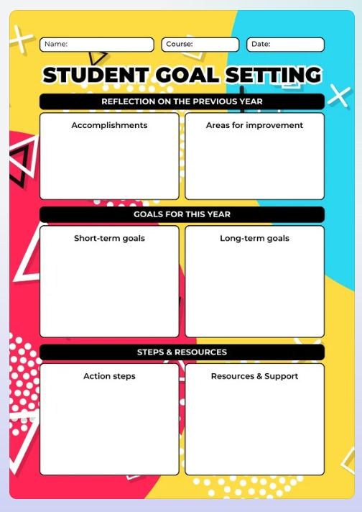
- Human resources (people).
- Material resources (tools & equipment).
- Informational resources.
- Training resources and Study materials.
- Research the best certifications.
- Enroll in a course or training program.
- Set study schedule (2 hours/day, 5 days a week).
- Join an online study group or community.
- Take mock exams and revise weak areas.
- Sit for the official exam.
- Apply new skills in your current job or volunteer projects.

- I have to improve my driving skills.
- My listening and speaking skills have to be improved.
- I have to improve collaboration with family and friends.
- Firstly, I have improved my mental, logical and cultural skills.
- Secondly, I have learned playing Table Tennis.
- I have improved my learning skills.
7/11/2025
BTECH-BT
Moulya C A
- Earn an advanced degree (master’s, PhD, or professional certification).
- Start and grow your own successful business.
- Build and maintain a healthy lifestyle (nutrition, exercise, mental health).
- Cultivate a meaningful daily routine or mindfulness practice.

- 💼 Career & Professional
- Reach a senior or leadership position in your field.
- Start and grow your own successful business.
- Become an expert or thought leader in your industry.
- Build a strong professional network and mentor others.

- 🎓 Education & Skills
- Earn an advanced degree (master’s, PhD, or professional certification).
- Continuously upskill through lifelong learning.
- Master a technical or creative skill (e.g., coding, public speaking, design).

- 💰 Financial
- Achieve financial independence or early retirement (FIRE).
- Buy a home or investment property.
- Build a diverse investment portfolio.
- Eliminate all debt and maintain long-term financial security.

- ❤️ Relationships & Family
- Build a strong, lasting partnership or marriage.
- Raise children and support their growth and education.
- Maintain close relationships with friends and family.
- Contribute to your community or volunteer regularly.

- 🌍 Lifestyle & Impact
- Travel the world or live abroad for a few years.
- Make a positive impact through social or environmental work.
- Write a book, start a foundation, or create something that leaves a legacy.

- Would you like me to help you create your own list of long-term goals (for example, 5 personal and 5 career-related ones)? I can tailor them to your interests or profession.

- Learn to play musical instrument that is violin.
- To learn classical dance (Kathak).
- To complete all the assignments which are assigned to me.
- To complete all these goals within 6 months.

